Interview #1:

Age: 21

What’s complicated: Making breakfast

Get food out: bacon, eggs, waffle mix

Get pans out

Put pans on stove

Turn on stove

Put the bacon in a pan

Let it cook

Crack eggs in a bowl

Stir eggs

Take bacon out of the pan

Rinse pan

Put the eggs in the pan

Cook eggs   
Put the eggs and bacon on a plate

Get a bowl for waffle mixing

Put the waffle mix in with an egg, flour and water

Stir the mixture

Plug in the waffle maker

Heat waffle maker

Cook the waffles

Take them out of the waffle maker

Put the waffles on a plate

Why it’s complicated: It is a long process just to eat the food that is cooked. There is a lot to keep organized.





Age: 53

What’s complicated: Getting ready for work in the morning

Find purse (in random location)

Walk around house looking for purse

Find shoes

Walk around house looking for shoes

Shoes look similar

Remember where clothes are for work

Gather water bottles and tea mug

Why it’s complicated: It is hard to find everything because it is often in different places.



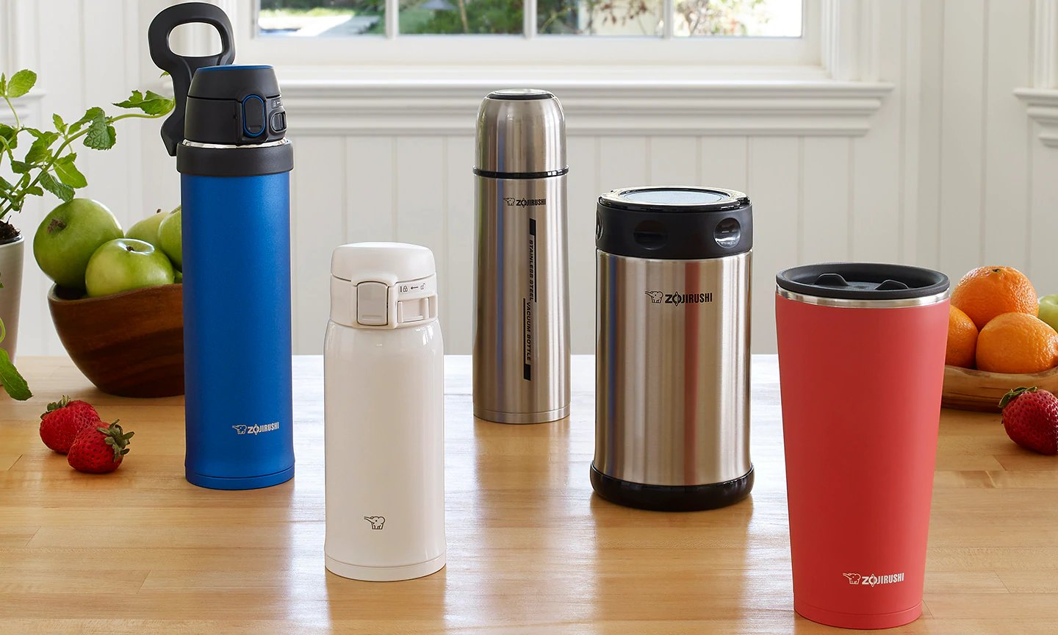

Age: 52

What’s complicated: Grocery shopping

Get items off of the shelves

Put them in the cart

Take the items to the register

Take them out of the cart to scan them

Put the items back in the cart

Pay for the grocery’s

Put the items in the car

Drive home

Take the items out of the car

Why it’s complicated: The items have to be moved around a lot.

